**Whose ………..is this?**

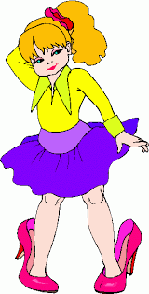

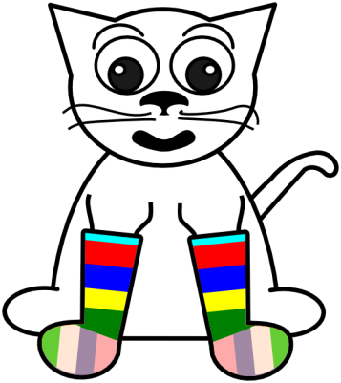



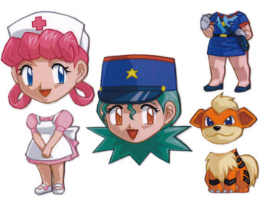

*a cat*

a

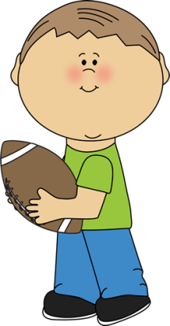

*Belle*

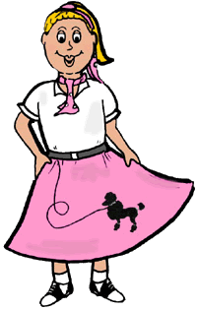

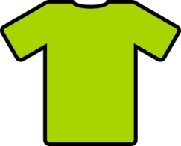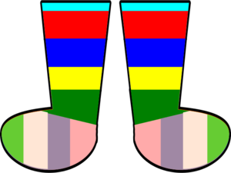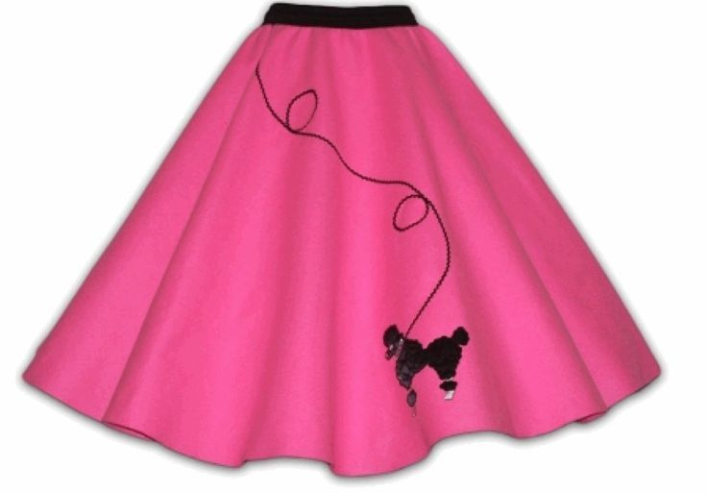

*This is_________________________*

*Ben*

*Tina*

*Jenny*

***skirt***

***hat***

***shirt***



***shoes***

***socks***

*This is_________________________*

*This is_________________________*

*This is_________________________*

*This is_________________________*