WORKSHEET

Name: ___________________________________________________ Class: _______ No _____
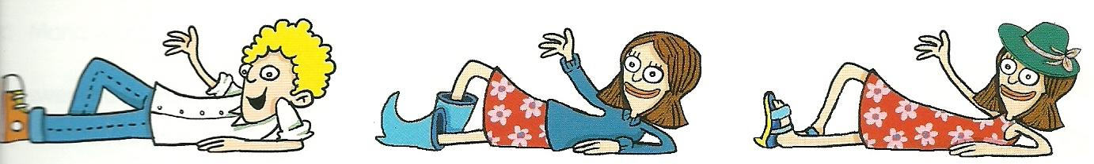
1. Look at the pictures. What are they wearing?

a.He is wearing____________ b._______________________ c._________________________
________________________ ________________________ __________________________
________________________ ________________________ __________________________

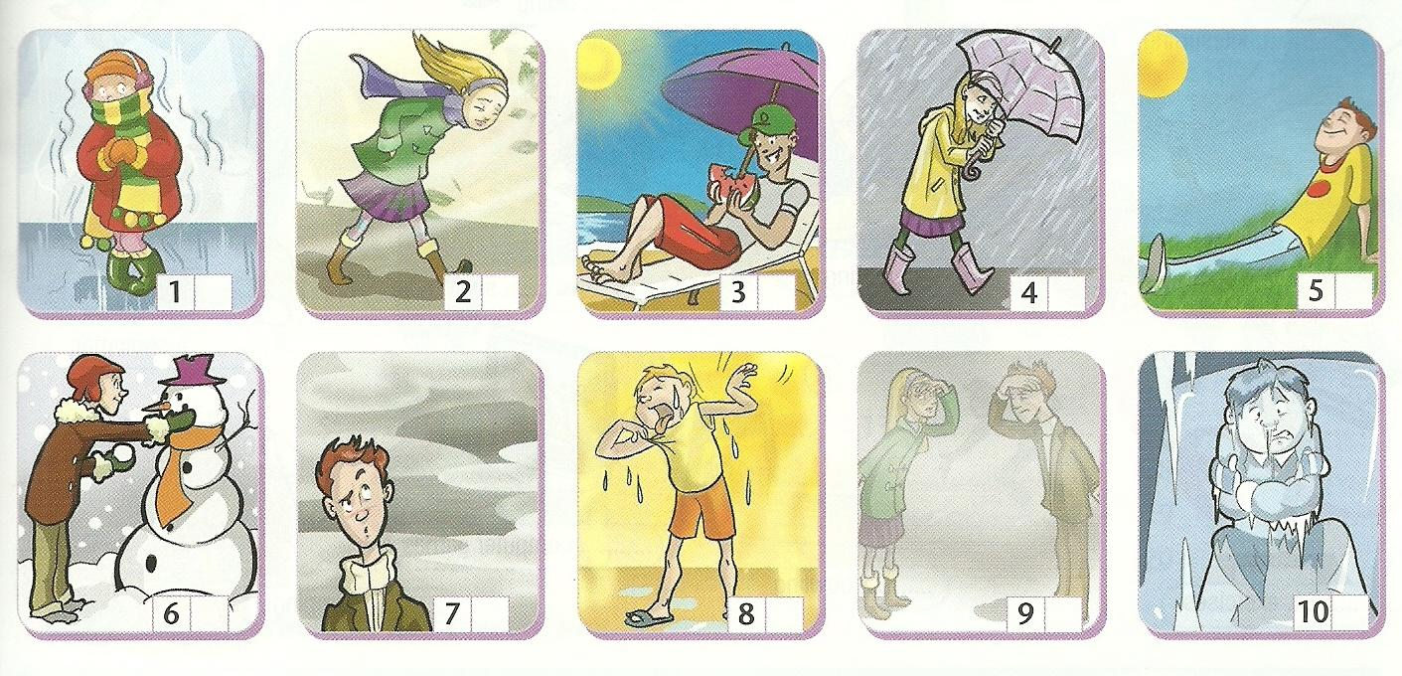
2. What’s the weather like?
foggy, snowy, sunny,
hot,
cold
rainy, cloudy, windy

warm

freezing

3. Write the seasons: Spring, Autumn, Summer, Winter.

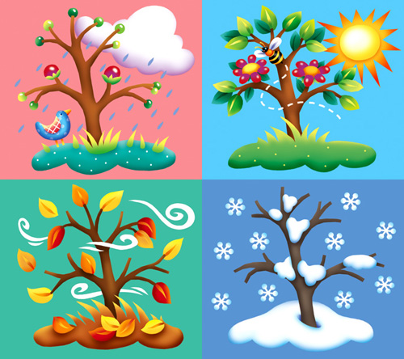
a.______________ b.______________

c._____________ d.______________

4. Label the pictures.
1.________________________
2.________________________
3.________________________
4.________________________
5.________________________
6.________________________
7.________________________
8.________________________
9.________________________
10._______________________
11._______________________
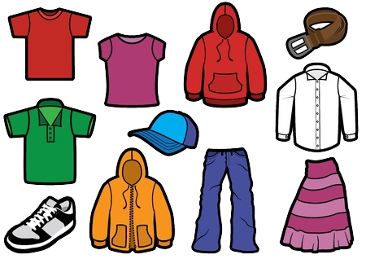
4

3
1
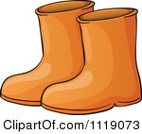
7
6

5
2
10
8
11
9
9
8

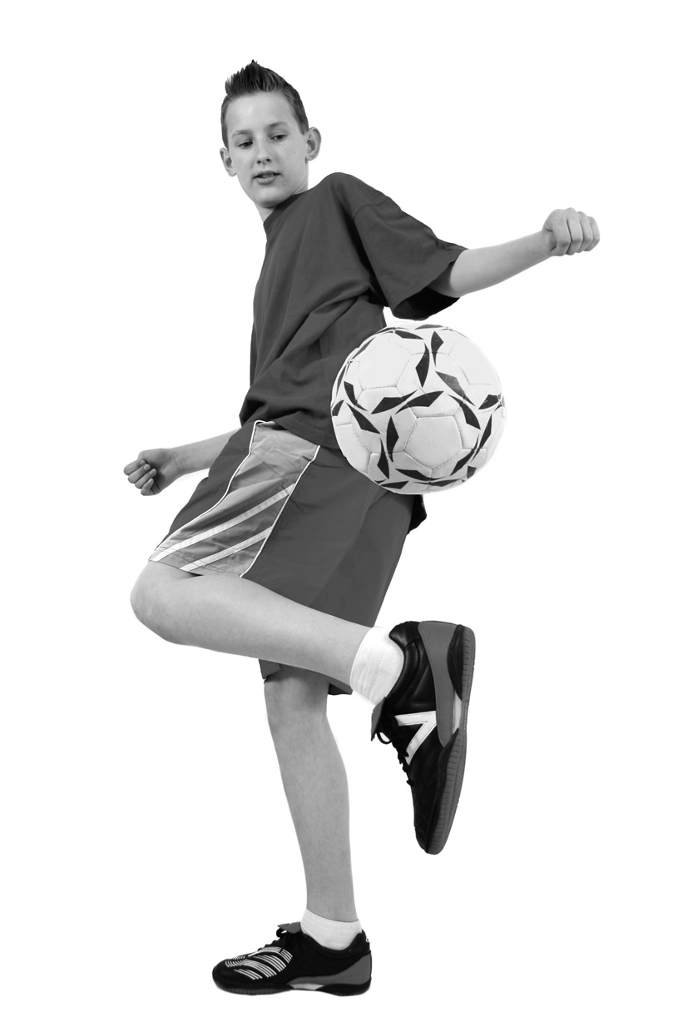
6
1
2
8
3
5. Label the picture: human body.
7
1. ____________________________
2. ____________________________
3. ____________________________
4. ____________________________
5. ____________________________
6. ____________________________
7. ____________________________
8. ____________________________
9. ___________________________
10. ___________________________

9

4
10
5

6. Complete the table.

Affirmative | Negative | Interrogative
a.Rachel goes t school by bus.
b. | We don’t watch TV.
c. |  | Does she like cereal?
d. | They don’t live in England.
e. You eat in the canteen.

7.Complete the sentences with some or any.

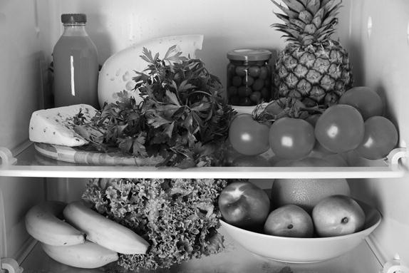
a. Are there _______ potatoes in the fridge?
b. There isn’t ________ water.
c. Look, there are ___________peaches.
d. There aren’t ____________ oranges
d. There is __________cheese in the fridge.
d. There aren’t ________beans.
e. Is there ________ meat?
f. Are there________ bananas?

8.Write the correct forms of the verbs in brackets.
a - Rachel usually_________(wake up) at seven o’clock but I __________(get up) at eight.
b – I ______( go) to work by car but my sister_______(go) by bus. She ______ ______ (not like) driving.
c. How ______ you _______ (come) to school ?
d. Rachel ______(watch) TV and then she ______(read) a book and _______(listen) to music.
e. Paul and his friends _________(not play) basketball.

9. Now answer about yourself. What are you wearing?

I’m wearing___________________________________________________________________________________
_____________________________________________________________________________________________

